Kevin O’Connor

Solzhenitsyn’s adopted state marks his 100th

(VTDIGGER. 2018. Sep 2. URL: https://vtdigger.org/2018/09/02/solzhenitsyns-adopted-state-marks-100th/)

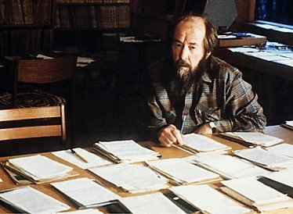
Russian writer Aleksandr Solzhenitsyn lived and worked
in the Vermont town of Cavendish from 1976 to 1994.
Photo from the Aleksandr Solzhenitsyn Center

CAVENDISH — Search for the exiled Russian writer Aleksandr Solzhenitsyn when he lived in this tucked-away Vermont town from 1976 to 1994 and the only thing you’d find is a sign at the general store that revealed “no restrooms, no bare feet, no directions to the Solzhenitsyn’s.”
A quarter-century after the now late Nobel laureate’s return to his native land, the store and the sign are gone, too. Some things, however, remain the same: “We still do not give directions to the Solzhenitsyn’s,” resident Margo Caulfield says.
That’s because locals continue to remember. Upon the centennial of the author’s birth, Cavendish is joining the state and literary world in celebrating the man who lived in the Windsor County town — population 1,381— longer than he did in any other community in his 89 years.
“He was extremely private,” says Caulfield, head of the Cavendish Historical Society, “but in many ways he was very much a Vermonter, and he has some really profound, timeless messages that humans need to understand.”
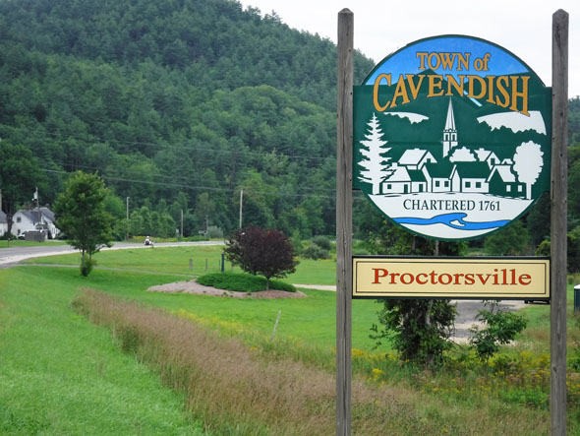
The Vermont town of Cavendish still remembers the late Russian writer Aleksandr Solzhenitsyn,
who lived and worked there from 1976 to 1994.
Photo by Kevin O’Connor/VTDigger

Caulfield won’t point out where the Solzhenitsyn family still owns property (“would you want me giving directions to your home?”) but she’ll guide anyone who asks to a current “Solzhenitsyn in Vermont” exhibit in Montpelier and coming “Reading Solzhenitsyn” conference in Lyndon.
Walk into the Vermont Historical Society’s capital-city museum through October and you’ll see how Solzhenitsyn, born Dec. 11, 1918, in Kislovodsk, Russia, won the Nobel Prize in Literature in 1970, only to face exile four years later for his criticism of the Soviet Union and communism.
The author spent two years in Switzerland before moving to the United States and Cavendish, which offered “a proper winter,” proximity to Dartmouth College’s library and, most importantly to him, privacy — the latter through a chain-link fence around his 50-acre property.
“I am sorry for that and ask you to forgive me, but I had to protect myself from certain types of disturbances,” Solzhenitsyn told residents at a subsequent town meeting. “The Russian people dream of the day when they can be liberated from the Soviet system, and when that day comes I will thank you very much for being good friends and neighbors and will go home.”
Caulfield, for her part, moved from her native Maryland to Vermont in 1987 and to Cavendish in 1991. There, she encountered the author’s mother-in-law, Ekaterina Svetlova.
“We were on the same schedule at the post office,” Caulfield recalls. “She’d always smile, always nod. She didn’t speak English, but she communicated with everyone, and everyone loved her.”
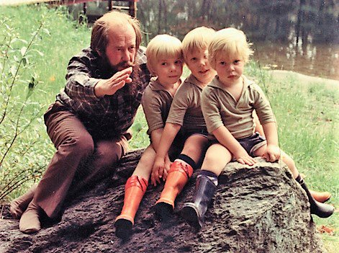
Russian writer Aleksandr Solzhenitsyn raised his sons in the Vermont town of Cavendish from 1976 to 1994.
Photo from the Aleksandr Solzhenitsyn Center

Caulfield first saw Solzhenitsyn at Cavendish’s 1991 state bicentennial celebration and once again when he said farewell at town meeting before returning to Russia in 1994.
“You were very understanding,” he told residents upon his departure, “you forgave my unusual way of life, and even took it upon yourselves to protect my privacy. For this, I have been grateful throughout all these years; and today, as my stay here comes to an end, I thank you.”
While in Cavendish, Solzhenitsyn taught his children Russian as their first language and wrote “The Red Wheel,” an epic cycle of novels about the Russian Revolution. His family, in turn, followed the Boston Celtics in the fall, winter and spring and mastered the American outdoor grill in the summer.
“The 18 years which I have spent here have been the most productive of my life,” he told residents. “Our whole family has come to feel at home among you. Exile is always difficult, and yet I could not have imagined a better place to live, and wait, and wait for my return home than Cavendish.”
Solzhenitsyn would continue to write in Russia until his death in 2008. Caulfield, for her part, has worked with his family on an oral history archive as well as the biographical book “The Writer Who Changed History” that Cavendish sixth-graders read each fall.
“It’s a fascinating story,” Caulfield says, “and there are lots of ups and downs.”
Caulfield will join international experts Sept. 7–8 at the “Reading Solzhenitsyn” conference at Northern Vermont University in Lyndon. Presenters will travel from Russia, China and, in the case of professor Kevin McKenna, the University of Vermont, which asked the author to visit when he was alive.
“I received a very kind letter,” McKenna recalls, “from his secretary, who explained ‘Aleksandr Isayevich (Solzhenitsyn’s middle name) no longer gives lectures on American college campuses. Yours will be no exception.’”
Solzhenitsyn nonetheless appreciated the state.

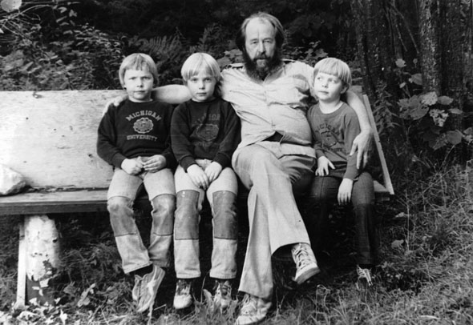
Russian writer Aleksandr Solzhenitsyn raised his sons in the Vermont town of Cavendish from 1976 to 1994.
Photo courtesy Vermont Historical Society

“The verdant trees and bucolic setting of Cavendish undeniably reminded him of the beauty of so much of central Russia,” McKenna says. “The morally righteous way of life in Vermont captured so many of the literary characters that Solzhenitsyn described in his novels and short stories. Lastly, the deeply practical-minded ethos of a shared democratic spirit lying at the heart of Vermont town meeting days accorded itself well with Solzhenitsyn’s deeply held beliefs of citizenship and personal responsibility.”
Both Caulfield and McKenna can tell coming-of-age stories about reading Solzhenitsyn’s 1962 novella “One Day in the Life of Ivan Denisovich,” which ends with a wrongly convicted prisoner recounting his previous 24 hours in a Soviet slave-labor camp.

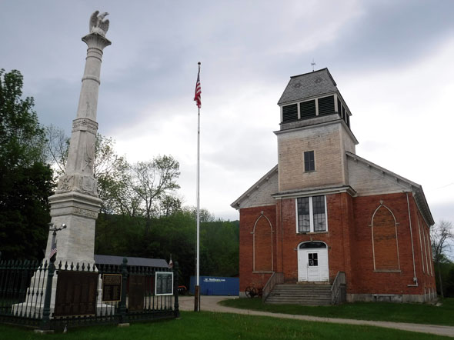
The Cavendish Historical Society features a collection outlining the time the late Russian writer
Aleksandr Solzhenitsyn lived and worked in town from 1976 to 1994.
Photo by Kevin O’Connor/VTDigger

“He’d finagled an extra bowl of mush at noon,” the book notes. “They hadn’t found the piece of steel in the frisk.”
Readers at the time hadn’t seen anything so graphic.
“This quiet tale has struck a powerful blow against the return of the horrors of the Stalin system,” the New York Times wrote in its review. “For Solzhenitsyn’s words burn like acid.”
Caulfield, for her part, notes “at the end of the day, he has his character counting gratitudes” — a current practice advocated in the emerging field of positive philosophy.
“There are so many levels on which you can read this man’s work,” Caulfield says. “He really understands and is able to write about the human condition.”
The University of Notre Dame Press is set to release the first English translation of Solzhenitsyn’s two-volume exile memoir “Between Two Millstones,” with his remembrance of the years 1974–1978 coming in October and the years 1978-1994 slated for release in the fall of 2019.

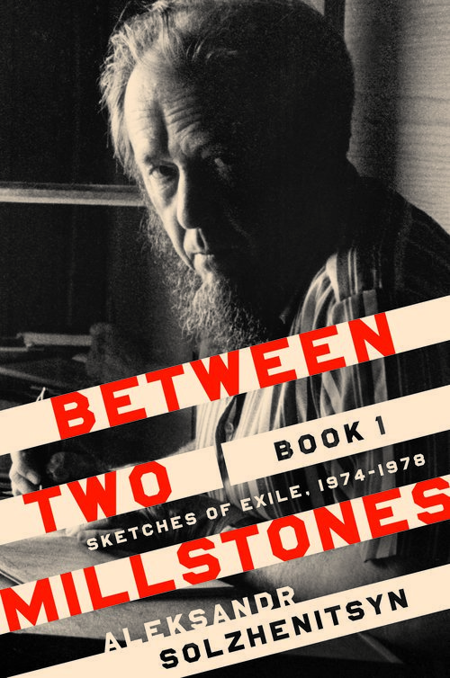
University of Notre Dame Press is set to release the first English translation
of Solzhenitsyn’s two-volume exile memoir

The Cavendish Historical Society, for its part, is working to create a permanent Solzhenitsyn collection at the former 1844 Universalist stone church on Main Street.
“For a little historical society, we have a very large charge,” Caulfield says. “I want to know that future generations can come here and have a good understanding of what his life was like when he lived here.”
Caulfield also is contemplating a 100th birthday party similar to the gathering Cavendish held after the author’s death.
“I would love nothing better,” she says, “than to have townspeople read their favorite lines and eat food he would have liked.”
The event also could continue another local tradition, Caulfield adds: “It wouldn’t be open to the media.”

